EXPT NO:4 | Visual encoding of data
DATE: 20.01.2026 | Visual encoding of data

PRE-LAB QUESTIONS
- How does the human visual system process visual variables?
The human visual system processes visual variables such as color, size, shape, and position by quickly detecting patterns, contrasts, and differences, allowing people to interpret complex data at a glance. It is especially efficient at recognizing spatial relationships and variations in color and size.

- Why is improper encoding misleading in analytics?
Improper encoding is misleading in analytics because it can exaggerate, hide, or distort data patterns, leading to incorrect interpretations and poor decision-making. Using unsuitable visual variables may cause viewers to misjudge trends, comparisons, or importance.

- What are perceptual limitations in visualization?
Perceptual limitations in visualization include difficulty in accurately comparing similar colors, small size differences, or complex shapes, especially when too many variables are displayed together. Cognitive overload can also reduce clarity and comprehension.

- How does color choice affect interpretation?
Color choice strongly affects interpretation because different colors carry perceptual and emotional meanings, influence attention, and determine readability. Poor color contrast or inappropriate palettes can confuse users or obscure critical insights.

- Why should AI dashboards be perceptually optimized?
AI dashboards should be perceptually optimized to ensure information is interpreted quickly, accurately, and without cognitive strain. Optimized visuals improve usability, reduce errors, and support reliable human-AI decision-making.

OBJECTIVE: To apply effective visual encoding principles for meaningful data communication.
SCENARIO: A city traffic department analyzes accident data to identify high-risk zones and accident severity patterns.
IN-LAB TASKS (Using R Language) • Encode severity using color gradients • Represent accident frequency using size • Use shape to indicate accident type

CODE:
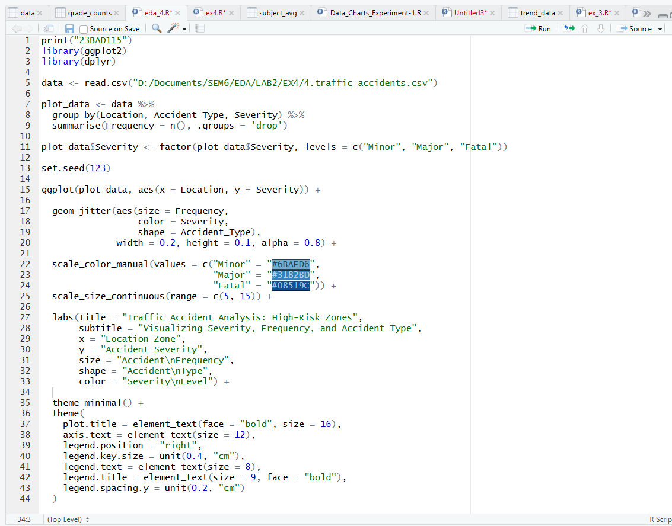

OUTPUT:
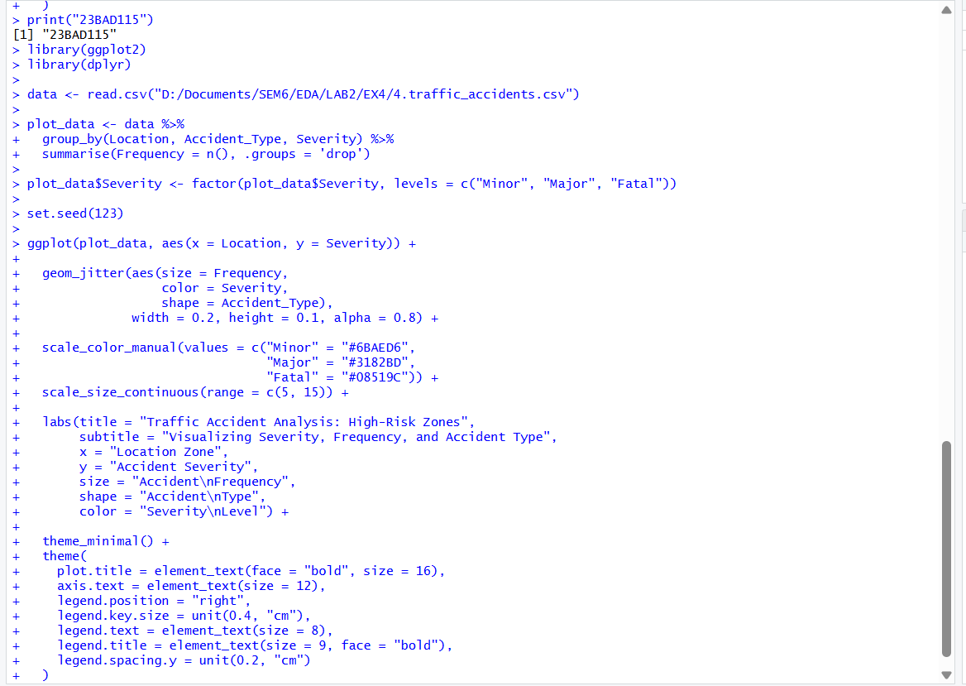

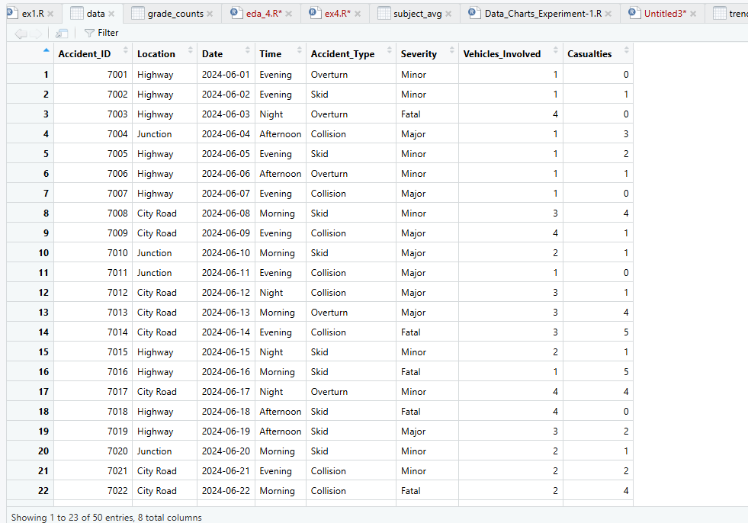

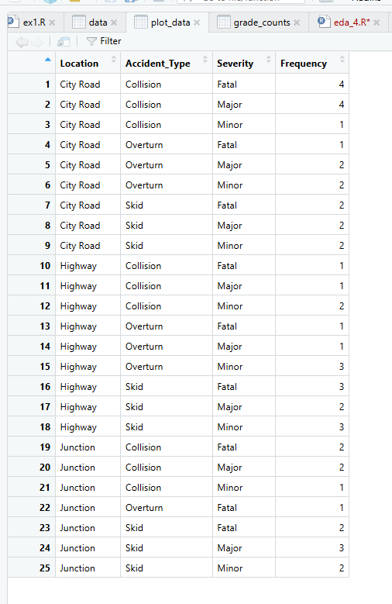

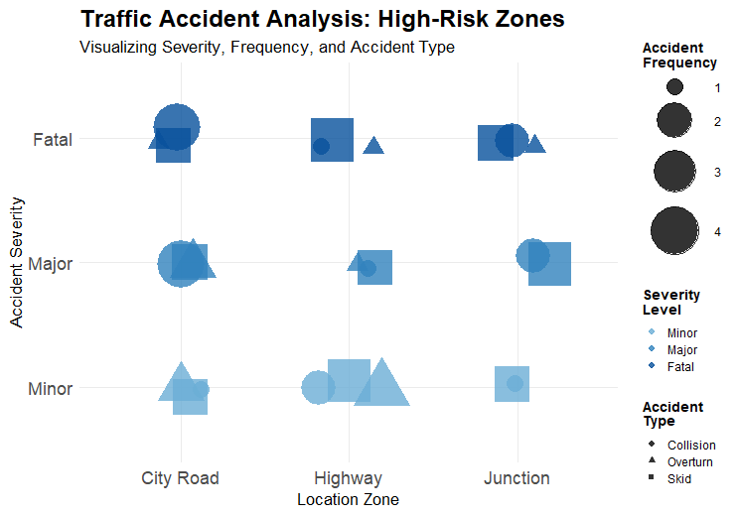

POST-LAB QUESTIONS
- Which visual variable best conveys severity and why?
Color encoding best conveys severity because it allows quick, intuitive differentiation between Minor, Major, and Fatal accidents. Humans perceive color differences faster than shape or size, making severity immediately recognizable across locations.

- How can poor encoding mislead policy decisions?
Poor encoding (e.g., similar colors for different severities or inconsistent size scales) can hide critical patterns, such as under-representing fatal accidents. This may lead policymakers to misallocate resources or underestimate high-risk zones.

- What precautions should be taken for color-blind users?
Use color-blind–safe palettes, ensure sufficient contrast, and avoid relying on color alone. Combining color with shape or position (as done with accident type shapes) improves accessibility and accurate interpretation.

- How does visual encoding affect AI explainability?
Clear visual encoding helps explain how patterns and features influence outcomes, making AI insights more transparent. Poor or cluttered visuals reduce trust and make it harder to justify AI-driven decisions to stakeholders.

- Suggest improvements for large-scale public dashboards.
Add interactive filters, tooltips with exact values, scalable legends, and responsive layouts. Simplifying visuals, using consistent encodings, and enabling drill-down views improves usability for diverse users.

LEARNING OUTCOME: Students learn perceptually effective visual communication for AI systems.

ASSESSMENT
Description | Max Marks | Marks Awarded
Pre Lab Exercise | 5
In Lab Exercise | 10
Post Lab Exercise | 5
Viva | 10
Total | 30
Faculty Signature

